Mission STEMCAP:
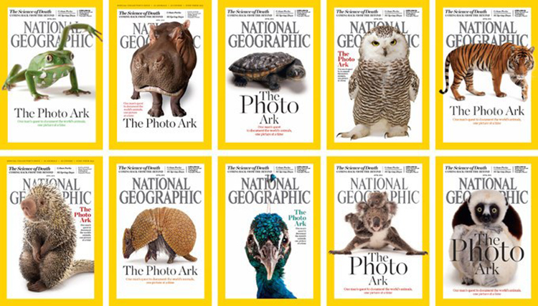

Tackling Extinction
“Help the world Thrive by Keeping Species Alive. ”

Decker Lake Youth Center
October 4th – 15th 2021
Day 1: Framing the Challenge

Today’s Goals: Understand what makes extinction a “grand challenge” and what we are going to do throughout Mission STEMCAP.

- List three things you learned about extinction today:

- Describe what you expect to learn and do during Mission STEMCAP.

- What is the difference between global and local extinction?

Discussion Questions:
- What are some reasons why humans should care about the extinction of other species?
- Why is biodiversity important and what are some ways we might help others care about protecting biodiversity and keeping species alive?
- So far, what aspect of extinction are you most interested in?

Days 2 & 3: Racing Extinction Film Discussion

Today’s Goals Recognize and discuss problems and solutions relating to biodiversity loss that are presented in the film Racing Extinction.

- What are the top 3 things that stuck with you from the film?

- What does the PhotoArk do and how could it inspire people to care about the effects of their actions on other species?

Discussion Questions:
- What is your reaction to the film? Do you feel moved, sad, hopeless, neutral, inspired to act? Were there any scenes that made you feel particularly emotional? Were you inspired to act? Why?
- What role do humans play within the narrative of the film? Can you think of any relationships between humans and the natural world that may have been left out? Why might the filmmakers have decided not to include those relationships?
- The film focuses on endangered animals and the threat of their extinction. What do you think would happen to the ecosystem where those animals live if they were to go extinct? How might other creatures be affected by the loss?

After watching this film what questions about extinction do you have? Think of some questions you might want to ask our local scientist, Bill, tomorrow.

Write one question you want to ask Bill about local extinction, or list one topic you want to know more about:

Day 4: Science Right Now
Today’s Guest: Bill Newmark

Today’s Goal: Understand the role of science in solving real-world problems and how Bill’s work can help inform conservationists.

- What does Bill study and what methods does he use?

- Why does local extinction matter?

Discussion Question:
- Bill showed us his methods of answering questions about local extinction, but science can take many different forms. How can we use the problem-solving processes of science to find solutions to things going on in our own lives that we might not think of as scientific problems?
- Are there any species you can think of that may have seen around of heard about as a kid that are no longer common to see around Salt Lake Valley?
- What do you think studying local extinction can tell us about global extinction?

Day 5: Utah Museum of Fine Arts Virtual Tour
Today’s Guest: Ms. Katie

Today’s Goal: Explore ways in which visual art can be used to tell stories and send messages about our world as you participate in a virtual tour of the Utah Museum of Fine Arts.

- What types of art (i.e.: paintings, sculptures, sketches) did you see on the tour of the Utah Museum of Fine Arts (UMFA)?

- How does the UMFA play a role in the fight against grand environmental challenges, like extinction?

- Does knowing the title of a work of art make you see details of the work differently than you would if you did not know the title? How?

Discussion Questions:
- Which work of art stood out to you the most? What was the art work depicting and how did the artist demonstrate that concept in a unique way?
- It is not always easy for people to go to art museums, what are some other ways that people can use art to make statements and spread information? What are some ways that the UMFA increases accessibility to the art in their collection?
- How might works of art help us better understand changes in our world?

Day 6: Art/Science – Creative Writing
Today’s Speaker: Laura

Today’s Goal: Understand the use of poetry as a way to express and respond to the issue of extinction.

Discussion Questions:
- Who is your imagined audience for your poem, in other words, who would you ideally like to read your poem?
- What imagery (or descriptive language) did you include in your writing? Why?
- What does poetry offer that scientific writing might not?
- Did you find it helpful or limiting to choose words from a page to create your poem?
- How did writing this piece help you reflect on extinction in a new way?

Day 7: Art/Science – Visual Art
Today’s Guest: Ms. Annie and Ms. Katie

Today’s Goal: Understand the role of visual art in helping us express ideas and engage with the world in a variety of ways.

- What is a Thaumatrope?

- What did you choose to draw on your Thaumatrope and how does it relate to the theme of extinction?

Discussion Questions:
- Has a work of art – a painting, a photograph, a drawing - ever inspired you in the past? In what way?
- Think back to Racing Extinction, how was art used in the film to communicate with the public?
- Can you think of a different art project that could help convey extinction issues to people?
- Why do you think artists use their artform as a way to teach about something or stand up for something they believe in?
- what is a topic that you care about and want people to pay attention to? How could art be used to communicate about it?

Day 8: CorRESPONDence – Starting a Conversation
Today’s Guest: STEMCAP Staff

Today’s Goals: Write messages about what you know and how you feel about extinction that you could use to start a conversation about the issue.

- What are three methods or tools for communicating about biodiversity loss?

- What is a non-profit organization?

- Why is it important to communicate about a problem with others?

Discussion Questions:
- Working for a non-profit organization is one way you can have a job that works toward preventing environmental issues like extinction, what other kind of job do you imagine you could have that could help prevent the loss of biodiversity?
- Who might you want to have a conversation with about extinction? Friends? Businesses? Community leaders? What kinds of things would you want them to know and what would you hope to learn from them?

